

**COURIER**

**MANAGEMENT SYSTEM**

***Wilson Sporting goods***

***E-PROJECT***



|  |  |  |
| --- | --- | --- |
| TEACHER | MISS FARYAL YAL GUL | |
| S# NO | **ENROLLMENT NO** | **STUDENT’S NAME** |
| 1. | 1603616 | MUBASHIR MEHMOOD |
| 2. | 1513874 | FARHANA AFTAB |
| 3. | 1512337 | MUHAMMAD ASAD KHAN |
| 4. | 1513259 | ALI AKBER |
| 5. | 1512331 | NOUMAN AHMED |

**TABLE OF CONTENT**

Contents

ABSTRACT 5

ACKNOWLEDGEMENTS 6

PROJECT SYNOPSIS 8

SCOPE OF PROJECT 9

PROBLEM STATEMENT 10

Hardware 10

Operating System 10

Software\\ 10

Admin 11

Agent 11

User 11

SYSTEM MODULES 11

MODULES DESCRIPTION 12

USER GUIDE 18

LOGIN: 18

REGISTER: 18

HOME: 18

ABOUT: 20

SERVICES: 20

CONTACT: 21

FEEDBACK: 22

FLOWCHART 28

**Task Sheet** 29

Project Ref. No. 29

Project Title 29

Date of Preparation of Activity Plan 29

Actual Days 29

status 29

# **ABSTRACT**

**Courier Management System** is a web-based application designed to streamline and automate the operations of a courier service. It provides a comprehensive platform for managing various courier activities, tracking parcel status, and handling orders in a simplified manner. The system includes different user roles such as **Admin**, **User**, and **Agent**, each with its own set of functionalities to ensure efficient handling of courier services.

**User Site**:  
The Courier Management System allows users to register, login, and view their profiles. Users can book a courier service by providing necessary details such as pickup and delivery address, package description, and weight. They can view the status of their active and past orders, track parcels in real-time using tracking numbers, and view a detailed history of their past shipments. Users can also request changes or cancel a courier service before dispatch.

**Admin Site**:  
The admin panel provides a centralized dashboard for administrators to monitor system activities in real-time. Admins can view and manage all users, agents, and orders. The dashboard includes statistical insights such as the total number of active users, newly registered users, and a comparison of monthly growth rates. Admins can add, edit, or delete user and agent information, view detailed reports on top-performing agents, and manage order statuses.

The admin can also add, edit, and delete courier categories (e.g., Same Day Delivery, Express Delivery) and manage parcels under these categories. If a courier service is temporarily unavailable, the admin can deactivate it instead of deleting it, making it invisible to users while retaining all records. Admins can also manage the visibility of certain services by marking them as featured or trending.

**Agent Site**:  
The agent role is responsible for processing and delivering the courier orders. Agents can view assigned orders, update the order status (e.g., Dispatched, Out for Delivery, Delivered), and add any relevant delivery notes. Agents can also mark orders as completed and notify users of successful deliveries. Each agent has access to their own dashboard, where they can view their performance statistics, active orders, and completed deliveries.

# **ACKNOWLEDGEMENTS**

Initially, we would like to express our deepest gratitude to Almighty ALLAH for giving us the strength, patience, and ability to successfully complete this project.

We would like to extend special thanks to our teacher, **Miss faryal**, for his unwavering support and valuable guidance throughout the development of the **Courier Management System** project. His expert advice and mentorship have been instrumental in shaping our understanding and execution of this project.

Lastly, we would like to acknowledge and thank our educational institution, **Aptech**, for equipping us with the necessary knowledge and skills to develop this system, and for providing a platform that fosters learning and innovation.

# **PROJECT SYNOPSIS**

The **Courier Management System** is a web-based application designed to provide users with an efficient and centralized platform for managing and tracking their courier services. This system simplifies the process of booking, tracking, and managing parcels, enabling users, agents, and administrators to perform their roles seamlessly.

COURIER

MANAGEMENT

SYSTEM

# **SCOPE OF PROJECT**

The **Courier Management System** project encompasses the development of a comprehensive online platform dedicated to managing the entire lifecycle of courier services, from booking and tracking to delivery confirmation. The system is designed to cater to the needs of three primary user roles: customers, agents, and administrators. The project’s scope involves creating a seamless and efficient platform that facilitates the management and tracking of courier services while providing a user-friendly experience for all stakeholders.

# **PROBLEM STATEMENT**

Courier management system is a management software designed by considering various factors in courier billing system. The proposed web app will help to manage customer information, package details, generate reports, app billing. Courier management web application will be a comprehensive and complete application will be able to manage all its operations and also the tracking and manage delivery info all registered consignments or packages, manage customer related information. The web app provide necessary info of status. Admin will update the details of both sender and receiver include status of booked package or consignment. User can tracking the courier through online site.

## **Hardware**

* A minimum computer system that will help you access all the tools in the

courses is a Pentium 166 or better

* 128 Megabytes of RAM or better

## **Operating System**

* **LINUX / Windows 2000 Server (or higher if possible)**

## **Software\\**

* PHP
* MySQL
* PERL
* Apache

# **SYSTEM MODULES**

## **Admin**

* Login
* New courier
* View all courier details
* Send SMS – From to
* Send delivery SMS
* Update/ delete courier
* Create agent
* Manage agent
* Manage customer details
* Status count
* Download report for shipment

## **Agent**

* Login
* New courier
* View all courier details
* Send SMS From to
* Send delivery SMS
* Status of branch
* Download report from branch

## **User**

* Register
* Login
* Track consignment number
* View status
* Print status

# **MODULES DESCRIPTION**

**Requirement Specification:**

The Web site is to be created based on the following requirements.

1. The Home Page should be created with proper sections and with a suitable logo.
2. Home Page should contain details of Sports Goods with suitable images.
3. The site should display a menu which will contain the options for brief introduction about the various sporting goods available, location of the shop and any other information if required.
4. The information should be categorized according to the brand names of the products like if a User wants to see only “REEBOK” products or any other companies products then he/she can click on a Link/button/menu etc and can see only that Brand products.
5. When a user selects any particular brand, a list of products for that brand will be displayed
6. A brief summary of features of individual products should be displayed on the Web Page along with the product but detailed Features should be stored in Individual Word documents which can be downloaded or viewed by the User who wishes to see the same.
7. The user should also be able to compare the various products of different as well as similar brands.
8. There should be a “Contact Us” page which will have the Address of the Company which is as follows and the mail address which when clicked will invoke the local mail client from where they can send an email.

***CODE***

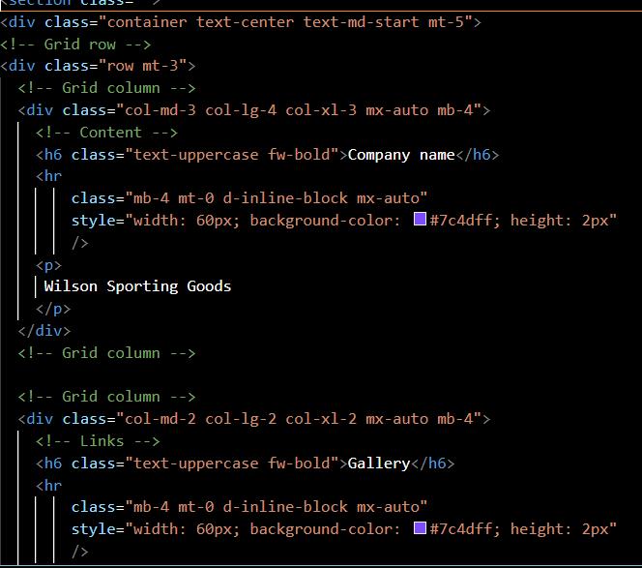

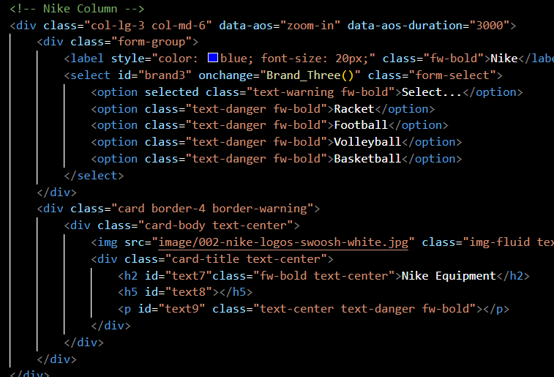

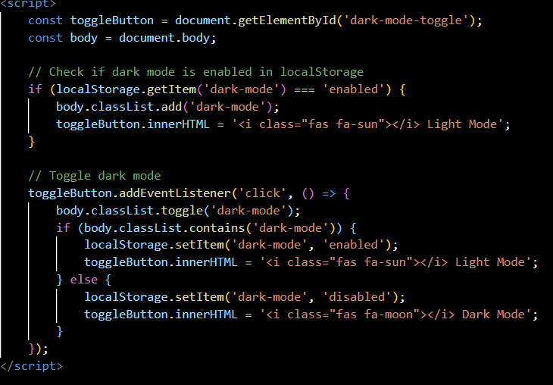

## 

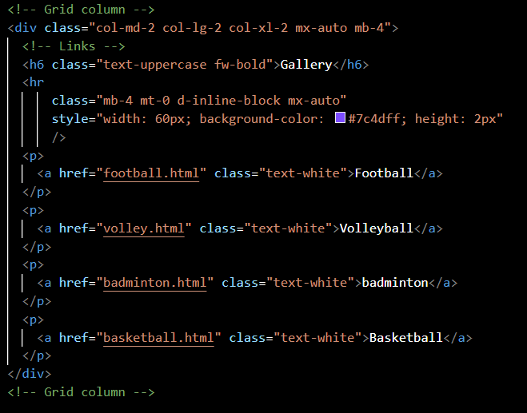

# **USER GUIDE**

## **LOGIN:**

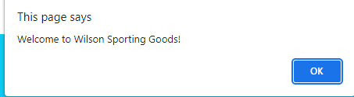

## **Untitled picture.png****REGISTER:**

## **HOME:**

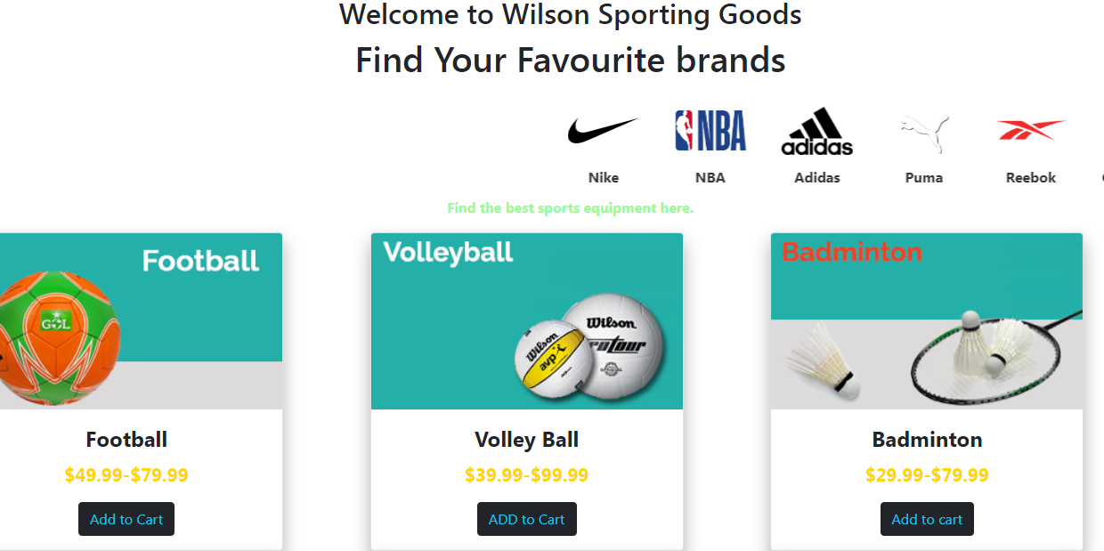

***PAYMENT FORM***

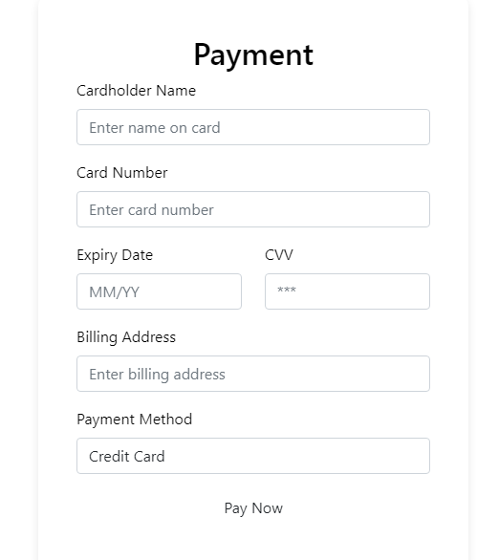

## **ABOUT:**

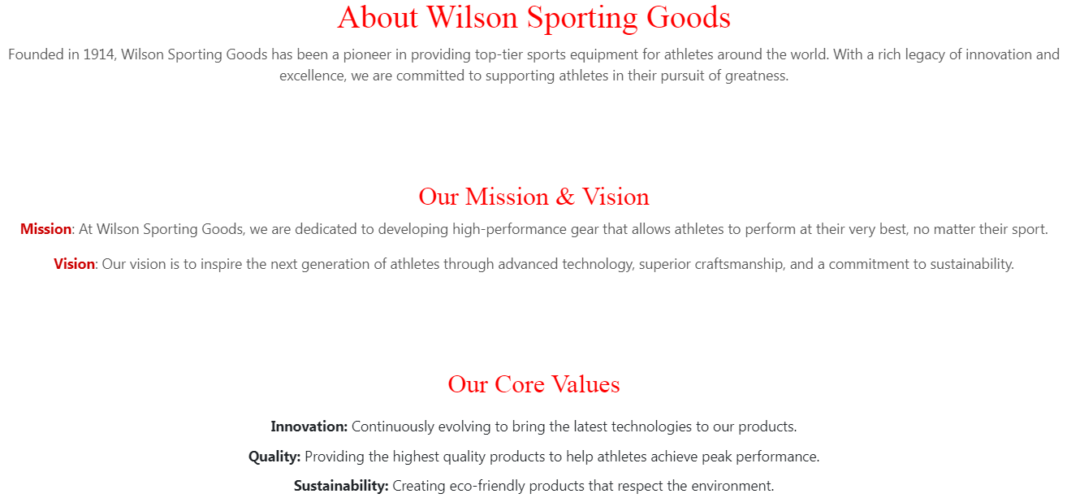

## **SERVICES:**

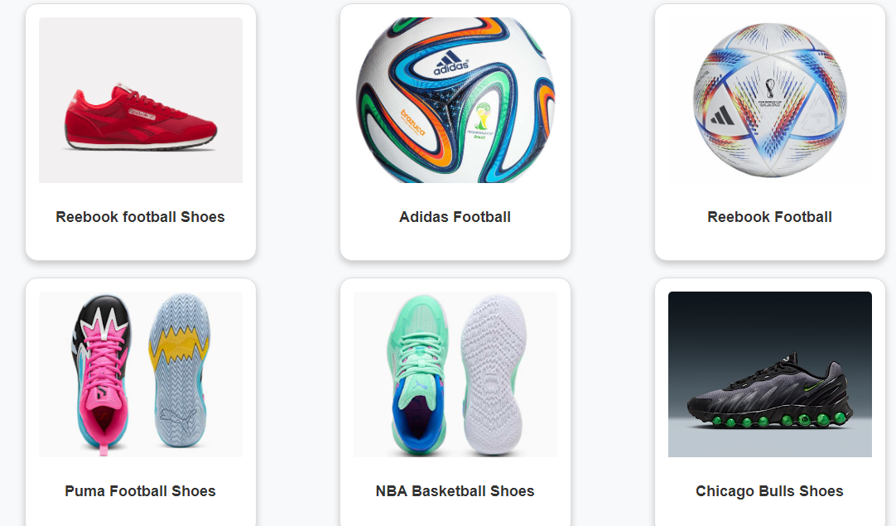

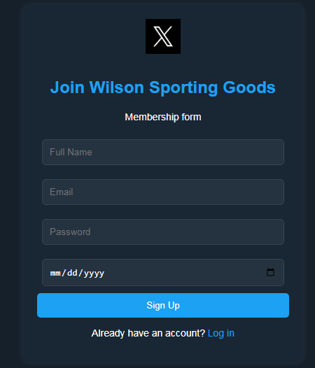

## **CONTACT:**

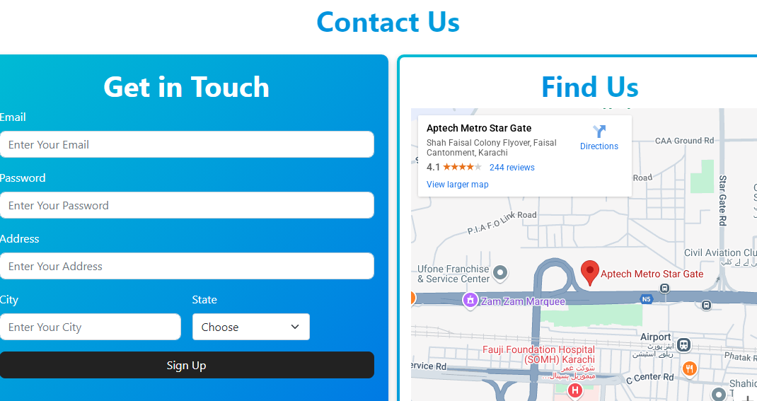

## **FEEDBACK:**

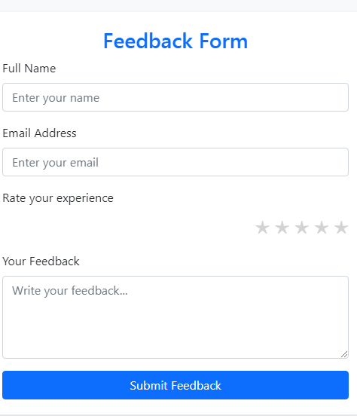

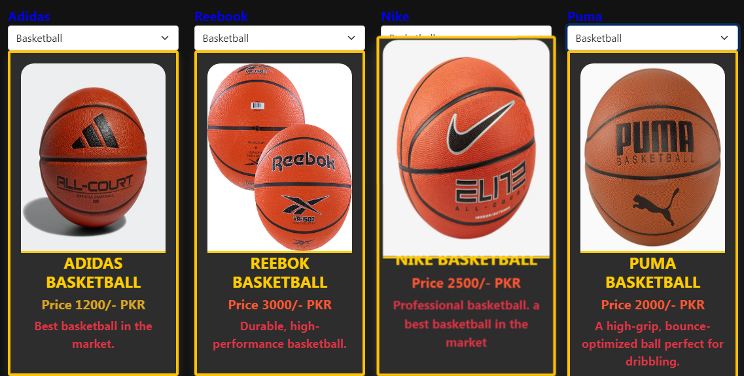

***COMPARE***

**PRODCUTS**

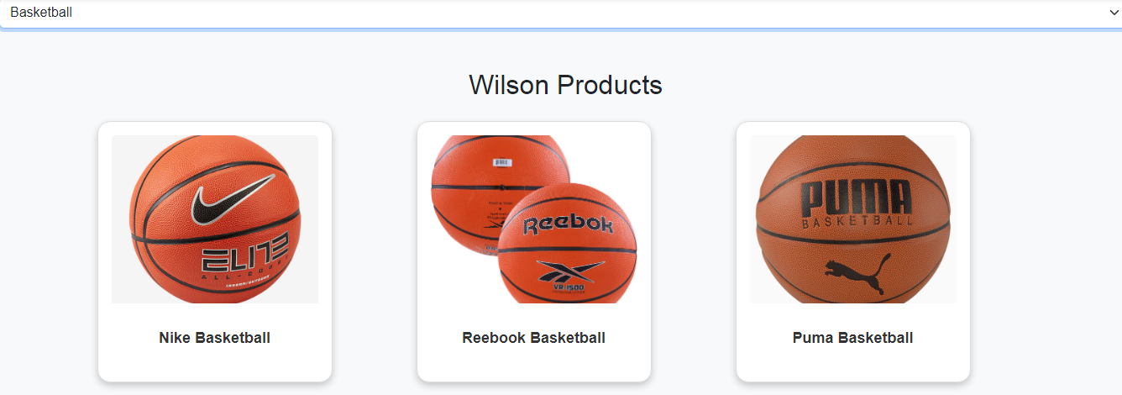



***FOOTBALL GALLERY***

**

***BASKETBALL GALLERY***

***BADMINTON GALLERY***

**

# **FLOWCHART**

**Task Sheet**

|  |  |  |  |  |
| --- | --- | --- | --- | --- |
| Project Ref. No. | | Project Title | Date of Preparation of Activity Plan | |
| S.No. | Ta | **Handicrafts** | Actual Days | Sstatus |
| 1 | Analysis | 1 |  |
| 2 | Design | 4 | OK |
| 3 | Development | 7 | OK |
| 4 | Testing | 1 | OK |
| 5 | Documentation | 1 | OK |